DAY 1 MONDAY, 24 APRIL 2017

Arrival of all participants.

WELCOMING AND INSTRUCTIONS
13.00 – 17.30 Welcoming.
Instruction, object visitation. Content of the student camp (explanation of the task, etc.).
19.00 Dinner.

DAY 2 - 4 TUESDAY, 25 APRIL 2017 – THURSDAY 27 APRIL 2017

WORKSHOP 1 and 2
9.00 – 15.00 Working or teaching time per day
The exact dates (including breaks) are included in the daily schedule, which will be handed over to participants on April 24, 2017.

DAY 5 FRIDAY, 28 APRIL 2017

PRESENTATION AND EVALUATION
9.00 – 11.00 Presentation of the work done in the workshops.
11.00 – 11.15 Break
11.15 – 12.00 Evaluation of the student camp / leave-taking (end of the student camp)
12.00 Lunch and departure

OBJECTIVE AND TASK
The aim of this camp is that students / trainees - with teachers / instructors - carry out the painting services required by the customer in a particular learning situation (learning scenarios).
The teachers / trainers will look after and observe the students / trainees in the execution of the performance, because the practical execution can vary nationally (different application techniques).
The Student Camp 2017 consists of 2 workshops.

LEARNING METHODOLOGY AND LEARN-SUPPORTING RESOURCES
- Project teaching
4-step method: explanation (preparation), demonstration (show / explain / imitate), application (explain, practice), correction (evaluate).
- Units of learning outcomes → Learning scenarios, assessment model
2 WORKSHOPS – CONTENTS

Workshop No. 1
- STENCILLING (Create a template and transfer to slide)
- MODERN HANDLING AND DESIGN OF OBJECTS WITH METAL LEAF (Metal leaf in gold, silver, copper)

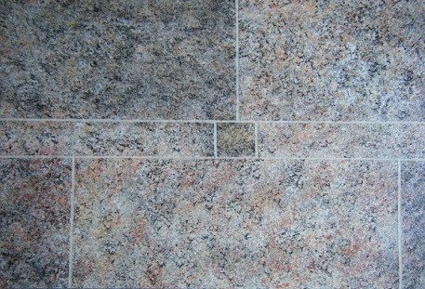

Workshop No. 2
- STONE IMITATION (Producing a surface similar to granite)
- ILLUSION PAINTING (Producing a masonry by light and shadow painting)

